Project Design Phase
Solution Architecture
Date | 28 September 2026
Team ID | 6ab221d587602313e82c60c9
Project Name | Import Data using Transform Maps (Spreadsheet)
Maximum Marks | 4 Marks
Solution Architecture:
Solution architecture is a complex process – with many sub-processes – that bridges the gap between business problems and technology solutions. Its goals are to:
- Find the best tech solution to solve existing business problems.
- Describe the structure, characteristics, behavior, and other aspects of the software to project stakeholders.
- Define features, development phases, and solution requirements.
- Provide specifications according to which the solution is defined, managed, and delivered.
Solution Architecture Diagram:
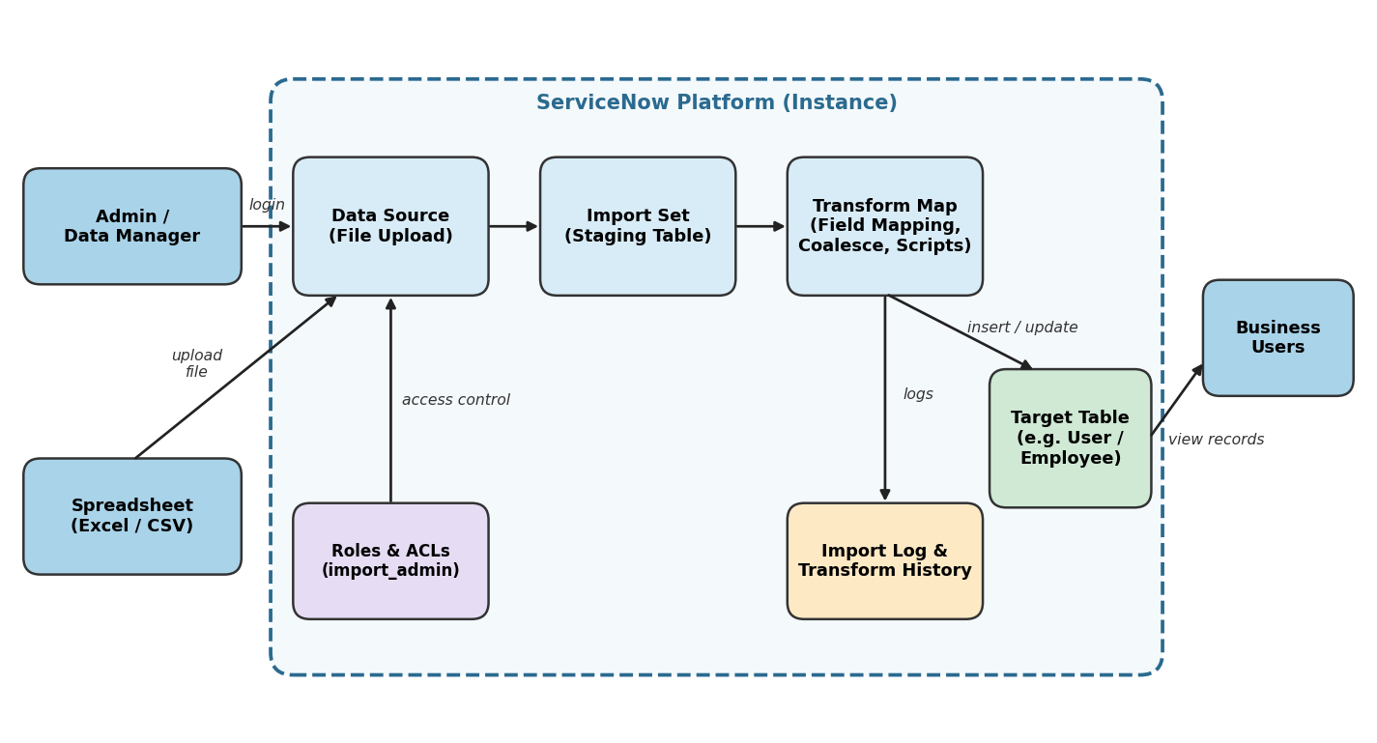
Figure 1: Architecture and data flow of importing spreadsheet data into ServiceNow using Import Sets and Transform Maps
Reference:
ServiceNow Product Documentation – Import Sets and Transform Maps (docs.servicenow.com)

